

**MOBILE APPLICATIONS DEVELOPMENT**

**TASK-5**

**Course Instructor:** Muhammad Ahmed **Total Marks: 10**

Student Name:Muhammad Haroon

Q: The ***android.widget.ListView*** is a view that used to display the data in the form of list and ***android.widget.ArrayAdapter*** that takes data from array and view it. Implement the suitable mobile application to display the month names of the year. After that user can search any month from list.

* Search month name any case letter (lower or upper).
* If user remove the month from search bar after that show whole list again.

☺☺☺☺ *Good Luck* ☺☺☺☺

Solution:

**Main Activity**

**Main Activity Xml:**

<?*xml version*="1.0" *encoding*="utf-8"?>  
<LinearLayout *xmlns:android*="http://schemas.android.com/apk/res/android"  
 *xmlns:app*="http://schemas.android.com/apk/res-auto"  
 *xmlns:tools*="http://schemas.android.com/tools"  
 *android:layout_width*="match_parent"  
 *android:orientation*="vertical"  
 *android:layout_height*="match_parent"  
 *android:background*="#926311"  
 *tools:context*=".MainActivity">  
  
 <SearchView  
 *android:id*="@+id/search"  
 *android:layout_width*="match_parent"  
 *android:layout_height*="wrap_content"  
 >  
  
 </SearchView>  
  
 <ListView  
 *android:id*="@+id/list_View"  
 *android:layout_width*="match_parent"  
 *android:layout_height*="wrap_content" />  
</LinearLayout>

**Main Activity Java:**

*package* com.example.listview;  
  
*import* android.annotation.SuppressLint;  
*import* android.os.Bundle;  
*import* android.widget.ArrayAdapter;  
*import* android.widget.ListView;  
*import* android.widget.SearchView;  
  
*import* androidx.appcompat.app.AppCompatActivity;  
  
*import* java.util.ArrayList;  
  
*public class* MainActivity *extends* AppCompatActivity {  
 ListView listView;  
 SearchView searchView;  
 ArrayList<String> arrayList;  
 ArrayAdapter<String> arrayAdapter;  
  
 @SuppressLint("MissingInflatedId")  
 @Override  
 *protected void* onCreate(Bundle savedInstanceState) {  
 *super*.onCreate(savedInstanceState);  
 setContentView(R.layout.*activity_main*);  
 listView = findViewById(R.id.*list_View*);  
 searchView = findViewById(R.id.*search*);  
 arrayList = *new* ArrayList<>();  
 arrayList.add("January");  
 arrayList.add("February");  
 arrayList.add("March");  
 arrayList.add("April");  
 arrayList.add("May");  
 arrayList.add("June");  
 arrayList.add("July");  
 arrayList.add("August");  
 arrayList.add("September");  
 arrayList.add("October");  
 arrayList.add("November");  
 arrayList.add("December");  
  
  
 arrayAdapter = *new* ArrayAdapter<>(*this*, android.R.layout.***simple_list_item_1***, arrayList);  
 listView.setAdapter(arrayAdapter);  
 searchView.setOnQueryTextListener(*new* SearchView.OnQueryTextListener() {  
 @Override  
 *public boolean* onQueryTextSubmit(String query) {  
  
 arrayAdapter.getFilter().filter(query);  
 *return false*;  
 }  
  
 @Override  
 *public boolean* onQueryTextChange(String newText) {  
 arrayAdapter.getFilter().filter(newText);  
 *return false*;  
  
 }  
 });  
 }  
}

**Main activity Design:**

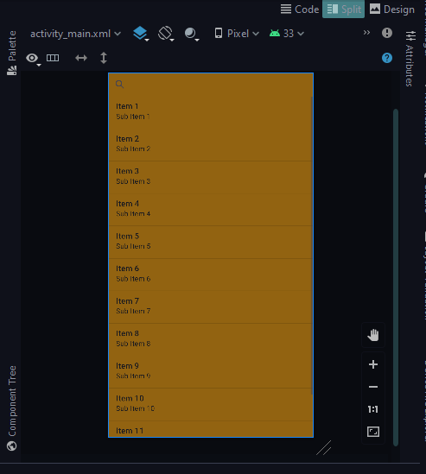

**<<<<<<<<<<<<<<<<<<<<<<<<<<<<<<The End>>>>>>>>>>>>>>>>>>>>>>>>>>>>>**